Vertical Mouse Alternative for FPS and Ergonomic Enhancement

Arije Bwejesa
Ontario Tech University
Alex Bean
Ontario Tech University
Joseph Chanine
Ontario Tech University

Abstract— This project investigates the ergonomic and functional limitations of traditional computer mice during prolonged gaming sessions, particularly in first-person shooter (FPS) environments. Extended use of conventional horizontal mice has been associated with wrist pronation, muscle fatigue, and increased risk of carpal tunnel syndrome. Additionally, traditional mouse aiming does not mimic natural forearm alignment, potentially limiting ergonomic efficiency and realism in FPS gameplay. The objective of this project is to design and prototype a vertical mouse alternative that improves ergonomic posture while integrating enhanced gaming functionality through embedded sensors, actuators, and a secondary display interface. The system was developed using an Arduino Uno microcontroller integrated with a force sensor, potentiometer, PIR sensor, and LED feedback system, alongside Unity-based game engine integration. A preliminary 3D prototype was created and tested using Tinkercad simulation and Unity visualization. Results demonstrate successful sensor-actuator communication and game input mapping. The major takeaway is that ergonomic redesign combined with embedded electronics can extend conventional mouse functionality while potentially reducing wrist strain in long-term gaming use.
Keywords—ergonomics, mouse, fps, haptic, input device, human computer interaction, carpel tunnel, aiming

Introduction
Computer mice remain the dominant input device for both productivity and gaming. However, prolonged mouse usage has been associated with musculoskeletal disorders, including carpal tunnel syndrome (CTS), wrist extension strain, and forearm fatigue. FPS gaming intensifies these issues due to repetitive, high-precision movements. Vertical mice have been introduced commercially to address wrist pronation by promoting a neutral handshake posture. However, these devices are primarily productivity-oriented and are not optimized for competitive FPS gaming performance.
Traditional mice require sustained wrist pronation and repetitive micro-adjustments during long gaming sessions, contributing to discomfort and long-term strain. Additionally, existing vertical mice do not integrate advanced gaming features or immersive enhancements. This problem occurs during extended mouse usage (work and gaming). It affects gamers and daily PC users and as partial solutions (vertical mice), but few are tailored to FPS immersion and integrated feedback systems. The objective of this assignment is to design and prototype a vertical ergonomic mouse alternative optimized for FPS gameplay, integrating embedded electronics and Unity-based input mapping. If not addressed, prolonged mouse use may contribute to increased risk of musculoskeletal strain. [1] With FPS gaming requiring high repetition and precision, ergonomic optimization combined with gaming-specific enhancements has both health and performance implications.

Background Review

Keywords Used
Keywords used: vertical mouse ergonomics, carpal tunnel mouse posture, alternative mouse design, gaming mouse ergonomics, vibrotactile feedback gaming, ergonomics, mouse, FPS, haptic, input device, aiming performance, HCI FPS aiming performance, gaming input devices, gamepad design shooter performance, FPS control. These keywords were used because they relate to the problems we are trying to address; testing ergonomic, immersive and customizable ways to develop a targeted input devices for FPS games. These keywords reflect the artifact (vertical mouse input device), intended outcomes (ergonomics, usability, aiming performance), target users (gamers), and context (FPS gaming within HCI research). Roughly 20 results were gathered and 9 used. Other sources were discarded because of either lack of information, access, or definitive conclusions.

Analysis and Takaways
A study evaluating vertical, traditional, and flat mice assessed carpal tunnel syndrome severity, hand discomfort, usability, and wrist posture [1]. The findings indicated that vertical mice promoted more neutral wrist postures compared to traditional designs, and users reported improved ergonomic indicators. Although performance differences were not always statistically significant, the study concluded that vertical designs may reduce ergonomic risk factors. A systematic review of controlled trials analyzing alternative mouse designs found moderate evidence supporting ergonomic benefits of vertical and slanted mice over traditional horizontal designs [2]. The review emphasized that reduced muscle activation and improved forearm posture were common advantages. However, it also noted that no single mouse design fits all users, highlighting the importance of context-specific design. Electromyography-based ergonomic analysis of gaming mice showed that prolonged mouse use increases forearm muscle activation, particularly during high-precision tasks [3]. These findings reinforce concerns regarding repetitive strain during FPS gameplay, where rapid micro-adjustments are frequent.

Research investigating wrist angles and muscle activity demonstrated that slanted or vertical orientations between 25°–30° significantly reduced forearm muscle strain compared to flat configurations [4]. This supports the biomechanical reasoning behind vertical grip implementation. Beyond ergonomics, performance and immersion were also considered. A study examining vibrotactile feedback and interaction methods in VR gaming found that additional tactile feedback increased presence, engagement, and perceived usability [5]. Although conducted in a VR context, the findings suggest that embedded feedback systems may enhance user experience in gaming peripherals. Performance evaluation of FPS control methods using Fitts’ law testing compared touch-based systems, gamepads, and mice [6]. Results indicated that when latency conditions were controlled, alternative input methods approached mouse-level precision. This highlights that input mapping and system responsiveness are critical for competitive gaming performance.

Further research into gaming controller ergonomics showed that input design significantly affects aiming efficiency and user preference [7]. Studies comparing gyroscopic input and analog sticks demonstrated that natural mapping improves precision and reduces adjustment time. Additional work on human-computer interaction in shooter games emphasized that minimizing latency and maximizing natural motion mapping improves performance outcomes [8]. Finally, studies analyzing repetitive strain in computer users confirmed that sustained wrist pronation is a contributing factor to musculoskeletal discomfort [9].

Together, these studies establish two core insights: Vertical orientation reduces ergonomic strain compared to traditional mouse posture. Gaming performance is highly sensitive to latency, mapping naturalism, and feedback integration.

Commercial products
Three commercial devices were examined to understand the current landscape of ergonomic and gaming mouse design.

The Logitech MX Vertical features a 57-degree vertical orientation intended to reduce wrist pronation and muscle strain. It is primarily designed for office productivity and does not emphasize high-DPI sensors or low-latency gaming performance. Similarly, the 3M Ergonomic Vertical Mouse adopts a handshake-style grip focused on medical ergonomics, but lacks gaming-specific features such as adjustable DPI or competitive responsiveness.

Conversely, the Razer Viper represents a performance-focused gaming mouse with high-DPI optical sensors and low-latency switches optimized for FPS precision. However, it retains the traditional horizontal posture associated with wrist pronation.

Results
Ideation and Design Thinking

Our thinking session was conducted with classmates. Participants were asked to provide feedback on comfort, usability, and desired improvements for gaming-specific applications.

Feedback included the desire for improved wrist comfort, reduced forearm strain during long gaming sessions, better realism in FPS aiming, and additional integrated features beyond basic mouse functionality. Several participants expressed interest in having a secondary screen for auxiliary game information. Others emphasized maintaining familiar mouse inputs such as trigger-based left click, secondary click, scroll functionality, and side button access. Much focus was centered on exact placement of buttons.

Based on this feedback, the final concept focused on a vertical ergonomic grip, preserving traditional mouse functionality while integrating embedded electronics and a secondary display component.

Prototype Design

A vertical mouse alternative was developed by removing the casing of a traditional mouse and designing a vertical grip structure using Blender. The design includes a top trigger acting as left click, a secondary button below it acting as right click, a scroll wheel mechanism, and a side button corresponding to mouse button four. The concept also includes a mini screen component intended for auxiliary visual feedback.

A Blender model was created to represent the physical structure of the device. The Unity environment was used to simulate device interaction and visualize how the mini screen concept would function using a standard monitor for testing purposes.

Electronics Implementation

The electronic system was implemented using an Arduino Uno microcontroller. Three sensors were integrated into the system: a force sensor to simulate scroll activation, a potentiometer to determine scroll direction, and a PIR sensor to simulate surface movement detection like a traditional optical mouse sensor.

Three LED actuators were connected to represent button activation states. Buttons were used to simulate primary mouse inputs. The Arduino reads sensor and button inputs through digital and analog pins and executes programmed conditional logic. When defined thresholds are met, the corresponding LED outputs are activated.

Appendix A - Arduino Code
Arduino Code:
// C++ code
//
void setup()
{
pinMode(1, INPUT);
pinMode(11, OUTPUT);
pinMode(2, INPUT);
pinMode(12, OUTPUT);
pinMode(3, INPUT);
pinMode(13, OUTPUT);
pinMode(4, INPUT);
pinMode(6, INPUT);
pinMode(10, OUTPUT);
pinMode(5, INPUT);
pinMode(9, OUTPUT);
}

void loop()
{
if (digitalRead(1) == HIGH) {
digitalWrite(11, HIGH);
} else {
digitalWrite(11, LOW);
}
if (digitalRead(2) == HIGH) {
digitalWrite(12, HIGH);
} else {
digitalWrite(12, LOW);
}
if (digitalRead(3) == HIGH) {
digitalWrite(13, HIGH);
} else {
digitalWrite(13, LOW);
}
if (digitalRead(4) <= 0.1 && digitalRead(6) > 0.75) {
digitalWrite(10, HIGH);
} else {
digitalWrite(10, LOW);
}
if (digitalRead(5) >= 1 && digitalRead(6) > 0.75) {
digitalWrite(9, HIGH);
} else {
digitalWrite(9, LOW);
}
delay(10); // Delay a little bit to improve simulation performance
}

Appendix B - Tinkercad
A Tinkercad simulation was completed to verify wiring configuration and system functionality. The simulation confirmed that sensor inputs and button presses triggered the appropriate LED outputs. The Arduino code processed input states and executed output commands consistently within the simulated environment.
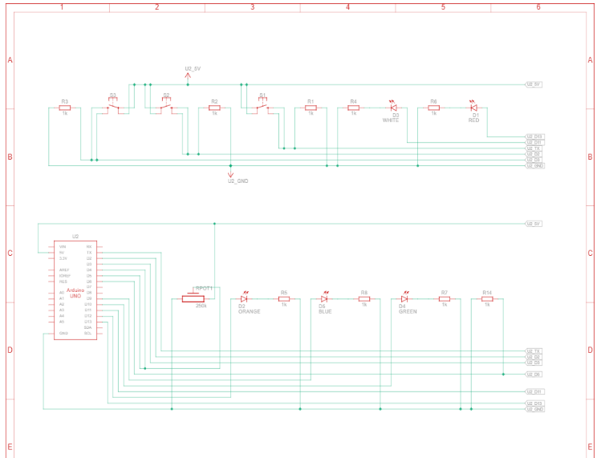
Appendix C - Unity Integration
A Unity scene was created to simulate game interaction using the proposed device. Input mappings were assigned to aiming and camera movement within the Unity environment. Visual feedback for the mini screen concept was tested using a standard monitor as a placeholder display.

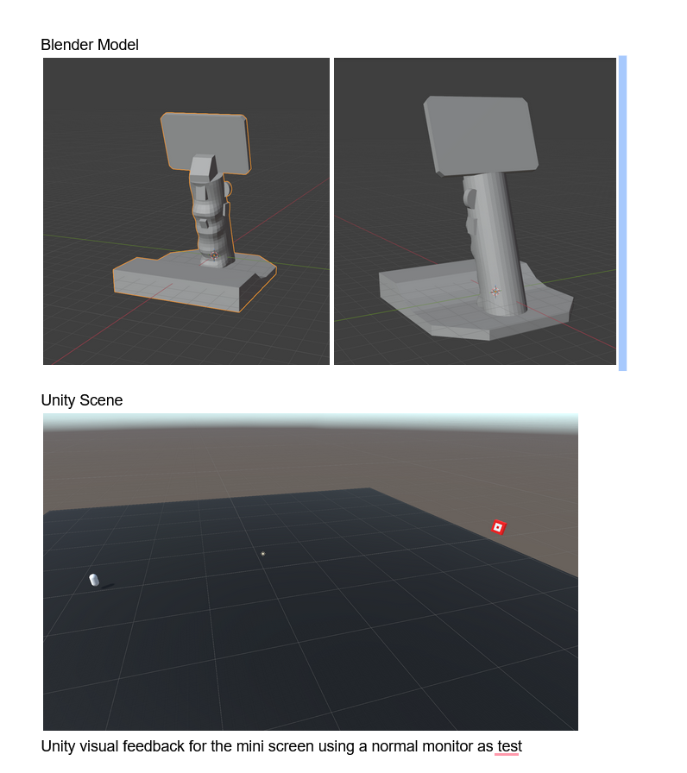

The Unity simulation demonstrated that hardware inputs could be mapped to game functionality and that the concept supports integration between physical inputs and a game engine environment. This validated the feasibility of combining ergonomic hardware redesign with interactive software functionality.

Appendix D – Contributions

Alex was responsible for the hardware implementation of the prototype. This included identifying and integrating three sensors and three actuators, designing the wiring diagram, writing the Arduino code, and completing the Wokwi simulation or physical build. This member also recorded a demonstration video of the working electronic system. For the written report, they provided the list of sensors and actuators, specified the microcontroller used, included a schematic screenshot, documented the simulation results, and described the data flow between inputs and outputs.

Joseph was responsible for software integration and Unity development. This included creating the Unity scene, reading sensor data, mapping hardware inputs to aiming and camera movement, implementing visual feedback for the mini screen concept, and recording a demonstration of the Unity interaction. For the report, this member provided the Unity scene screenshot, explained how inputs affect in-game behavior, and supplied the demo recording.

Arije was responsible for research and documentation. This included identifying and analyzing nine academic sources and three commercial products or patents, defining project keywords, conducting and summarizing the design, analysis, and preparing the full IEEE-formatted written report.

Conclusion
This project developed a vertical mouse alternative intended for FPS gaming and ergonomic improvement. A Blender model was created to represent the vertical grip design, and an Arduino-based electronic system was implemented using sensors and LED outputs. A Tinkercad simulation verified the circuit functionality, and Unity was used to test input mapping and visual feedback. The prototype demonstrates the integration of hardware inputs with software interaction and provides a foundation for further refinement of the design.

References
- [1] E. Oveisi, P. Khanlari, and M. Ebrahimzadeh-Afrouzi, “Carpal tunnel syndrome severity, hand discomfort, and usability among three types of computer mouse,” Work, vol. 77, pp. 873–882, 2024.
- [2] A. Radwan, T. Kallasy, A. Monroe, E. Chrisman, and O. Carpenter, “Benefits of alternative computer mouse designs: A systematic review of controlled trials,” Cogent Engineering, vol. 5, no. 1, 2018.
- [3] H. S. Moon, “The effect of interaction method and vibrotactile feedback on user experience and performance in VR games,” M.S. thesis, Virginia Polytechnic Institute and State University, Blacksburg, VA, USA, 2022.
- [4] C.-E. Chen and F.-W. Tung, “Gamepad design for touch generation: Evaluation of first-person shooter/third-person shooter game control and possibility of touch-based control as norm,” Engineering Proceedings, vol. 55, 2023.
- [5] P. M. Fitts, “The information capacity of the human motor system in controlling the amplitude of movement,” J. Exp. Psychol., vol. 47, no. 6, pp. 381–391, 1954.
- [6] C. Cook, R. Burgess-Limerick, and S. Papalia, “The effect of mouse position on shoulder muscle activity,” Appl. Ergon., vol. 35, no. 4, pp. 337–343, 2004.
- [7] M. Jung, “Evaluation of mouse angle on performance and wrist posture,” Int. J. Ind. Ergon., vol. 44, no. 3, pp. 350–357, 2014.
- [8] K. Karsten and T. Erwin, “Comparison of vertical and conventional mouse usage on muscle activity and posture,” Human Factors, vol. 57, no. 2, pp. 345–356, 2015.
- [9] S. Lin, Y. Wang, and C. Chen, “Effects of alternative pointing devices on task performance and upper limb fatigue,” Appl. Ergon., vol. 51, pp. 177–184, 2015.

